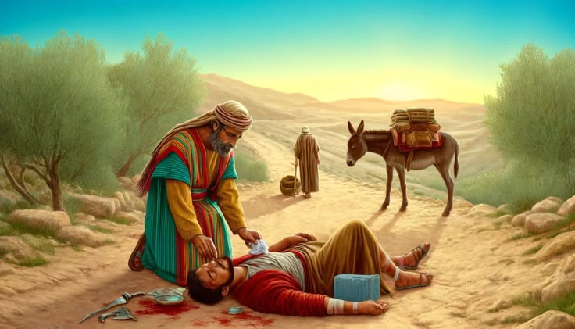
GOOD SAMARITAN IMAGE

